40. Draw Rectangular Shape and Extract Objects Using OpenCV
Aim
To draw a rectangular shape around an object and extract the selected object from an image using OpenCV.
Algorithm
- Import OpenCV.
- Read the input image.
- Select the coordinates of the object.
- Draw a rectangle around the object.
- Crop the rectangular region from the image.
- Display the original image with the rectangle.
- Display the extracted object.
- Save the extracted object if required.
Python Program
import cv2

# Read the image
image = cv2.imread("object.jpg")

if image is None:
print("Image not found!")
exit()

# Rectangle coordinates
x = 100
y = 80
w = 250
h = 200

# Draw rectangle
cv2.rectangle(
image,
(x, y),
(x + w, y + h),
(0, 255, 0),
2
)

# Extract object
cropped = image[y:y+h, x:x+w]

# Display images
cv2.imshow("Original Image", image)
cv2.imshow("Extracted Object", cropped)

# Save extracted object
cv2.imwrite("extracted_object.jpg", cropped)

cv2.waitKey(0)
cv2.destroyAllWindows()
Output 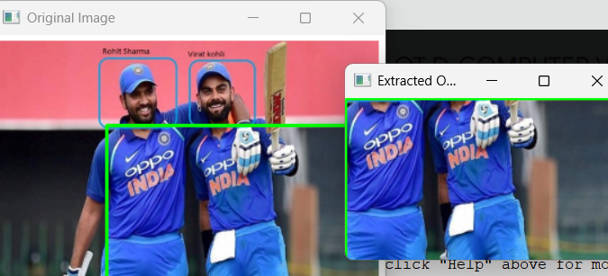Result
Thus, a rectangular shape was successfully drawn around the selected object and the object was extracted from the image using OpenCV.

